HD 27631

HD 27631 is a 0.94 M☉, G3 IV/V star1. Based on 60 RV CORALIE measurements obtained between 1999 and 2012, a study performed in 2013 (hereafter M13)1 reported a GP signal with a period of 2208 ± 66 days, a minimum mass of 1.45 ± 0.14 MJup and an eccentricity of 0.12 ± 0.06. The CH survey reported a GP signal with properties close to those reported in the M13 study.

In the present study, in addition to the M13’s data[1], 25 RV HARPS measurements obtained between 2014 and 2020 were considered. DPASS and MCMC (1000 walkers and 300000 iterations) were used to fit the data. The properties of HD 27631b are close to those reported in the CH survey.

The fits are shown in Fig 1, and the corner plot in Fig 2, and the results summarized in Table 1.

Conclusion:The properties found in the CH survey for HD 27631b are confirmed.

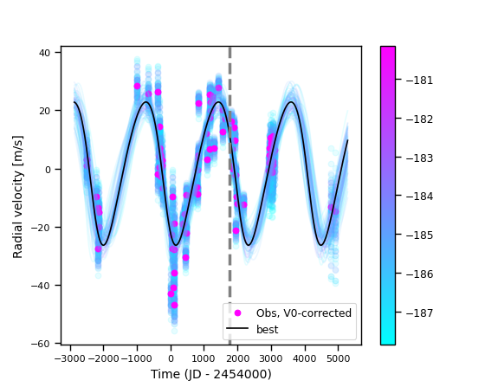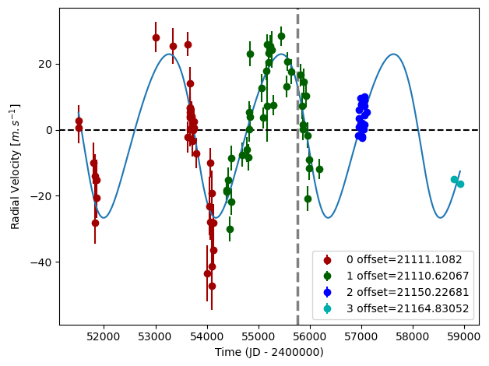

Figure 1: Left: fit of the HD 27631 RV with DPASS. Red - C98, green - C07, blue - H03, cyan - H15. The blue curve shows the best fit. Right: fit of the RV using MCMC. The black curve shows the best fit. The colorbar corresponds to the log-likelihood of the fits. The gray dotted line indicates the end of the CH survey.

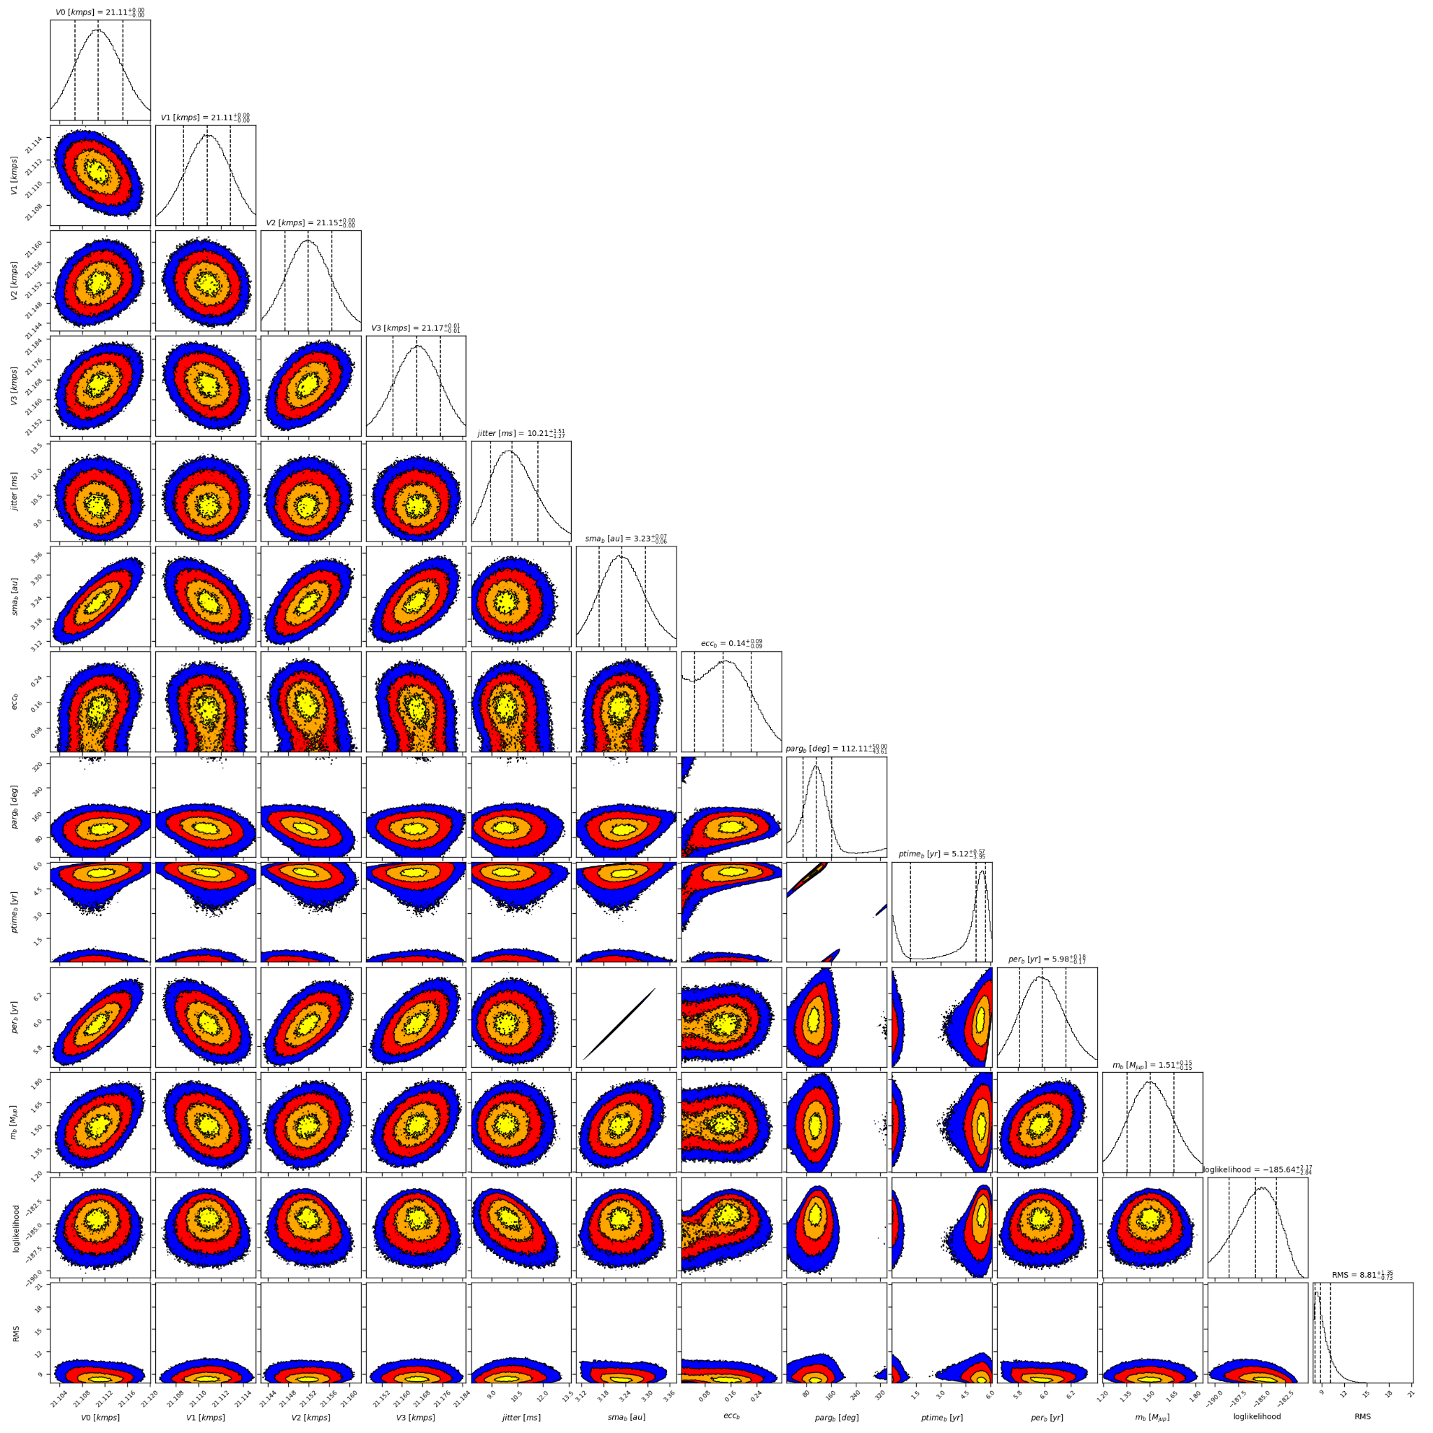

Figure 2: Corner plot of posteriors for the one-planet model MCMC fit of HD 27631 RV data.

| Parameter | Priors | | Posteriors | | CH survey |
| --- | --- | --- | --- | --- | --- |
|  | DPASS | MCMC | DPASS | MCMC |  |
| *a* (au) | [2,80] | [1,10] | 3.23 | 3.23 ± 0.06 | 3.1 |
| Msin(i) (MJup) | [0,100] | [0.1,10] | 1.5 | 1.5 ± 0.2 | 1.7 |
| Eccentricity | [0,0.95] | [0,0.9] | 0.15 | 0.04 – 0.22 | 0.17 |
| Instrumentals offsets (km/s) | [-60,60] | [20.5,21.5] | C98: 21.111  C07: 21.111  H03: 21.150  H15: 21.165 | C98:  C07: 21.111 ± 0.002  H03: 21.152 ± 0.005  H15: |  |
| Stellar jitter (m/s) | [0,40] | [0,20] | 8.8 |  |  |
| Argument of periastron (°) | [0,360] | [0,360] | 85.7 |  |  |
| Phase | [0,1] | [0,1] | 0.42 | 0.20 – 0.95 |  |

Table 1: HD 27631. Summary of priors and posteriors with DPASS and MCMC, compared to the properties reported by CH Survey.

References

1. Marmier, M. et al. The CORALIE survey for southern extrasolar planets XVII. New and updated long period and massive planets. *Astron. Astrophys*. 551, A90 (2013).

1. The CORALIE data used were not available on the CDS database; therefore these data were recovered from DACE; they are not exactly the same as those used by M13 study1 (72 RV CORALIE data against 60 RV CORALIE data). Yet, the RV curve obtained for the CORALIE dataset was the same.